1. Mismatch No record available message display in list grid 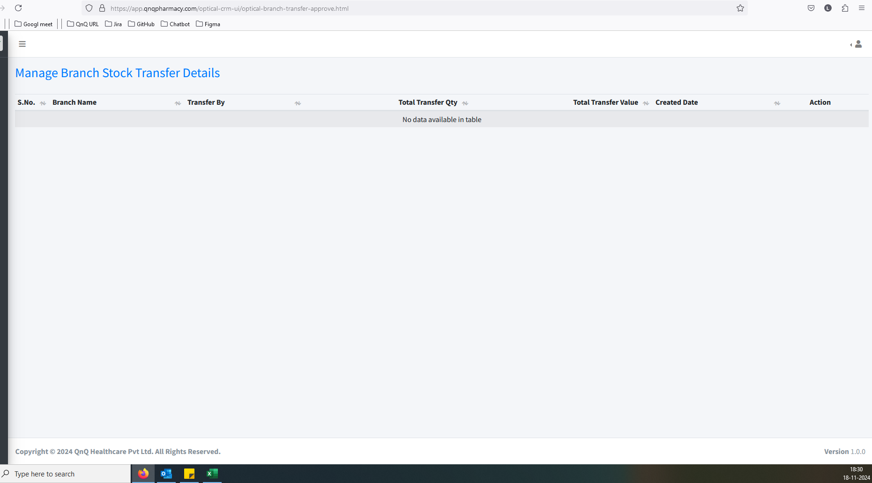//
2. Showing records and Pagination not display in approve list grid 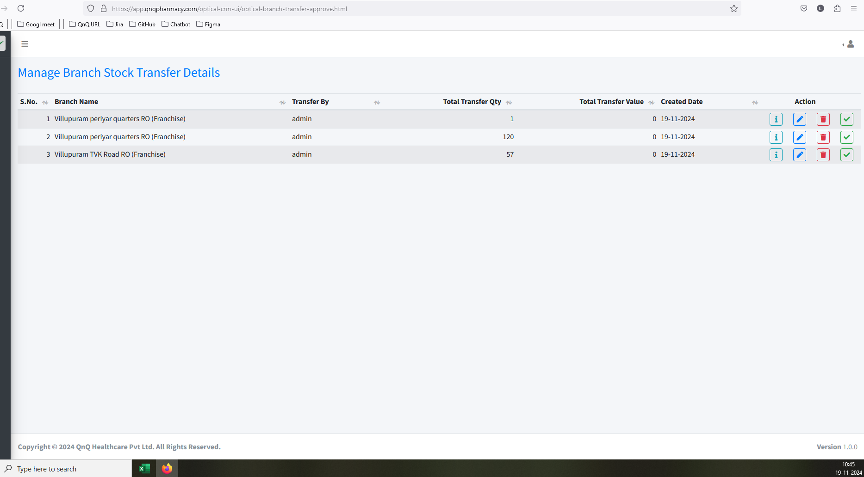 //
3. Screen header/title name display mismatch content 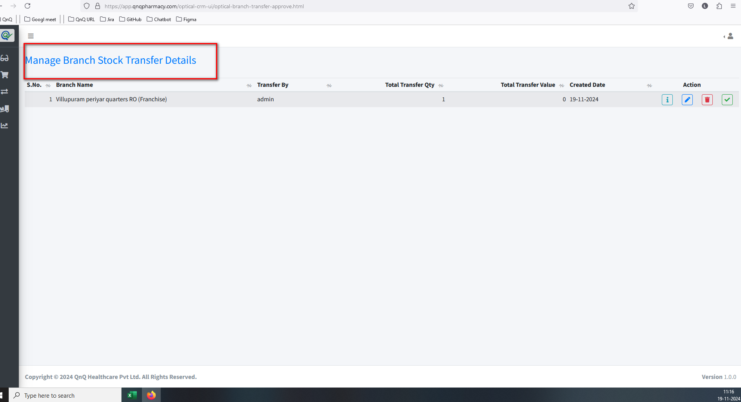 //
4. Improper alignment display in list grid 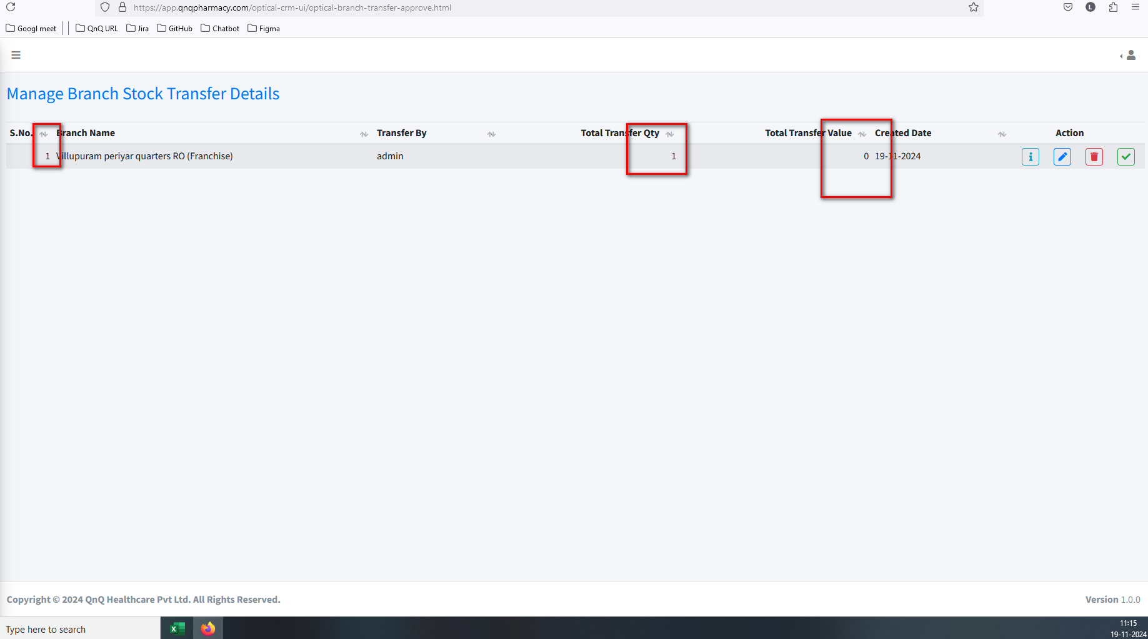 //
5. Unable to reject the pending transfer approval records 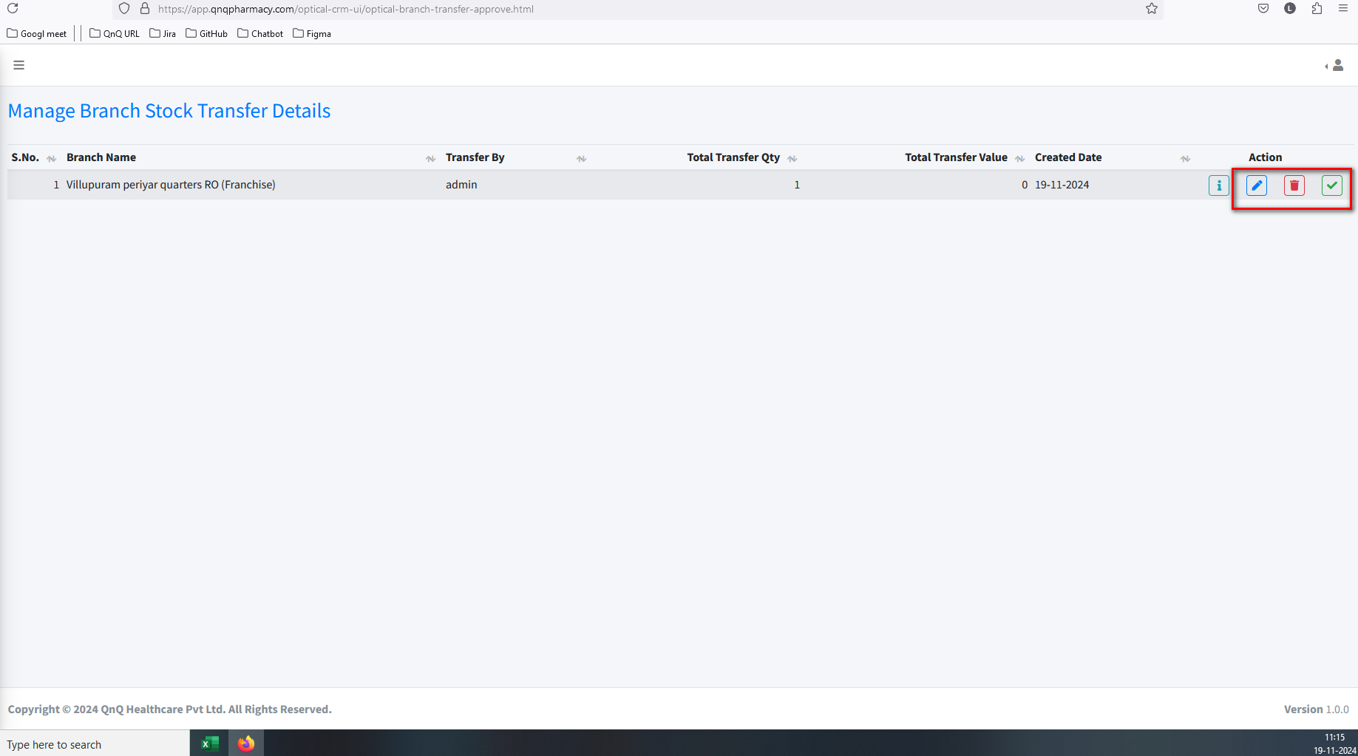 //
6. Unwanted Edit and Delete option available in Approval screen 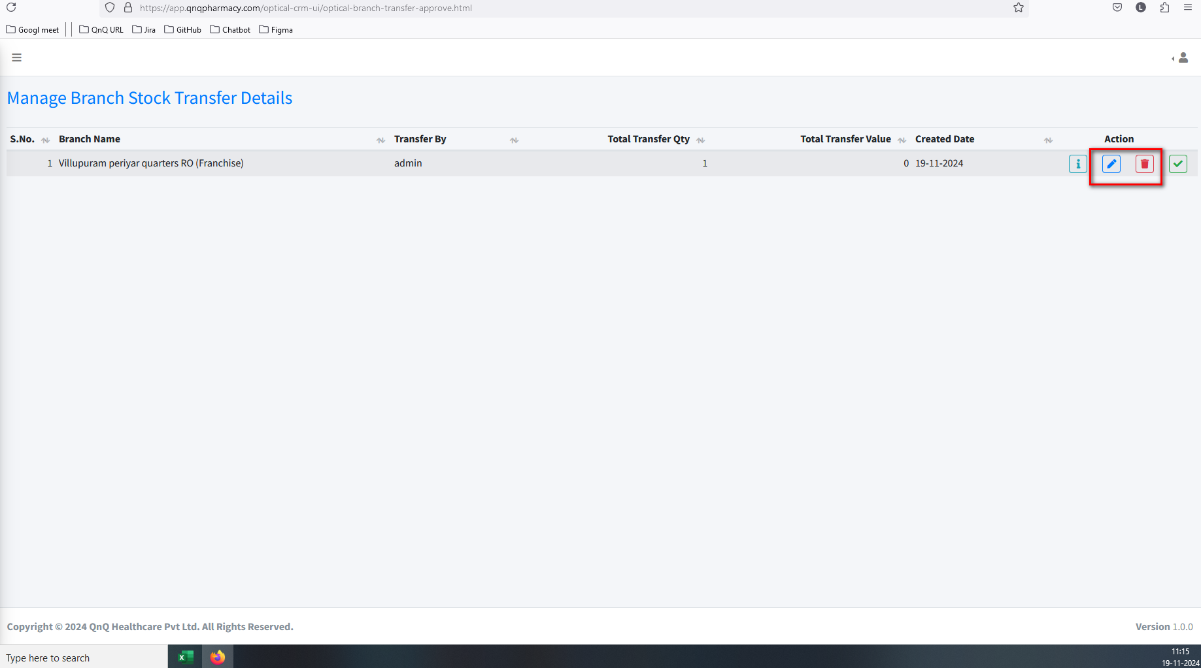 //
7. Mismatch column name display in list grid 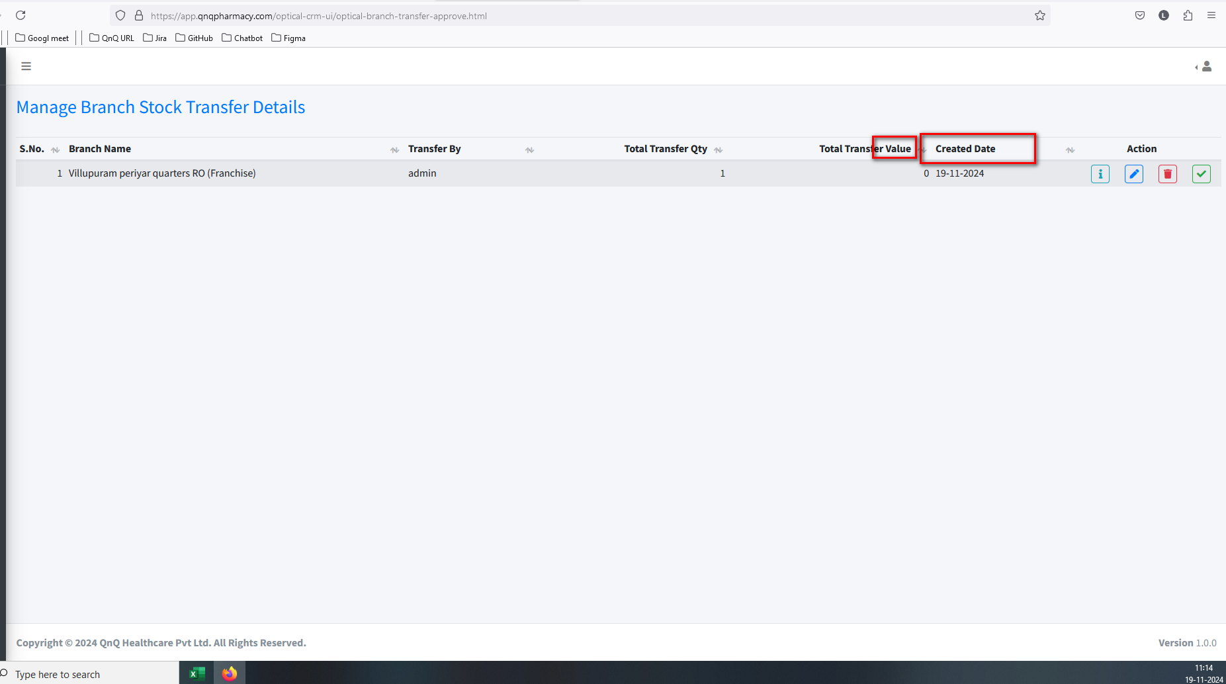 //
8. Excessive space is column name and sort icon 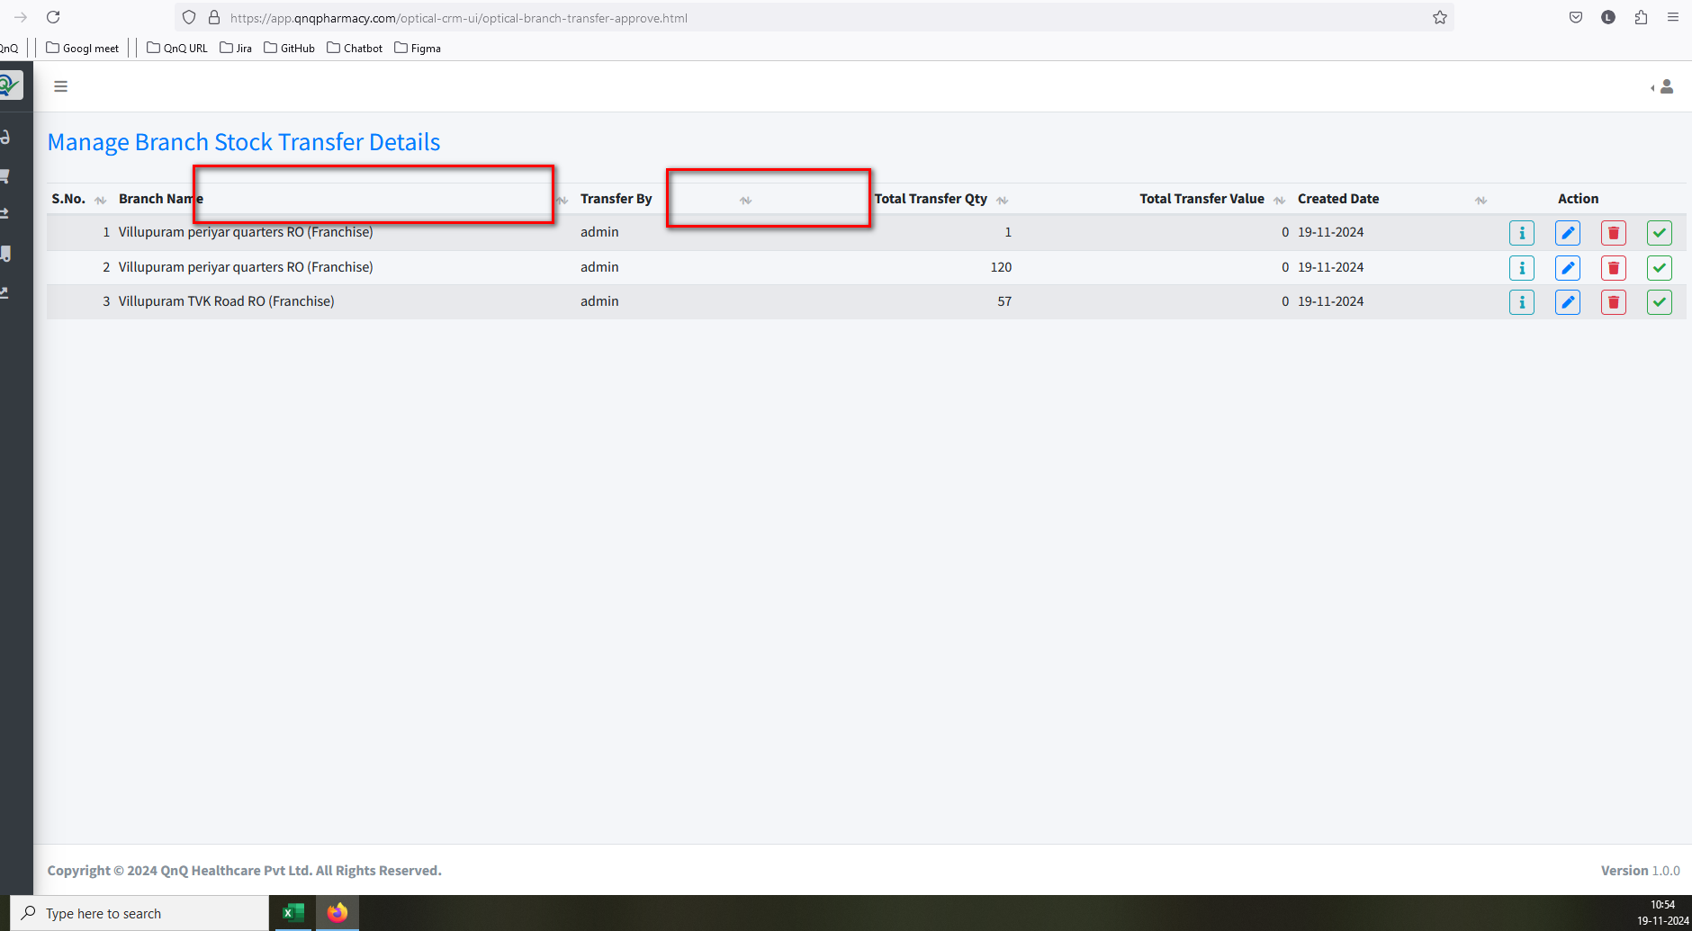 //
9. Search filter and Refresh options not display in approval list grid 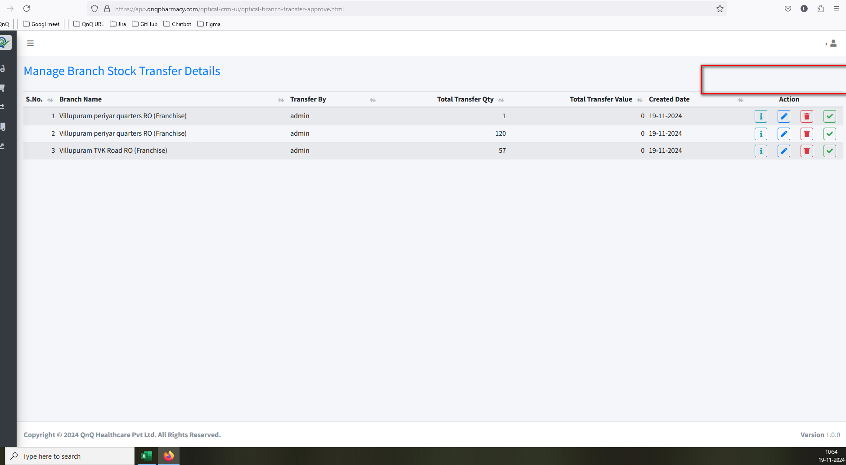 //
10. Excel Import options not available in approval list grid 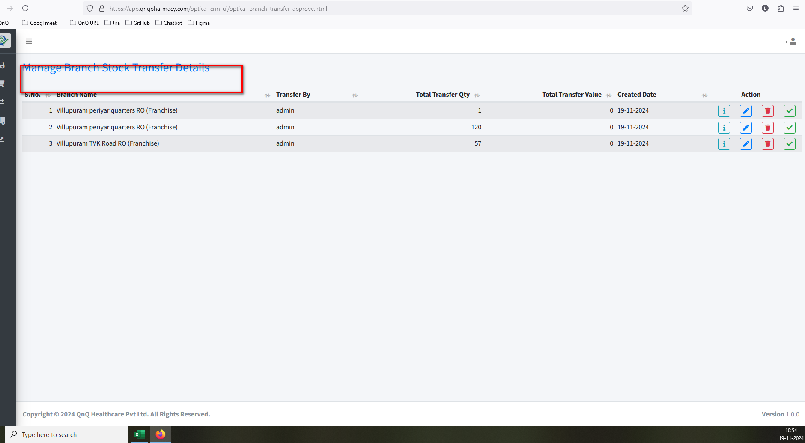 //
11. The navigation suggestion does not appear in the Rate History List grid 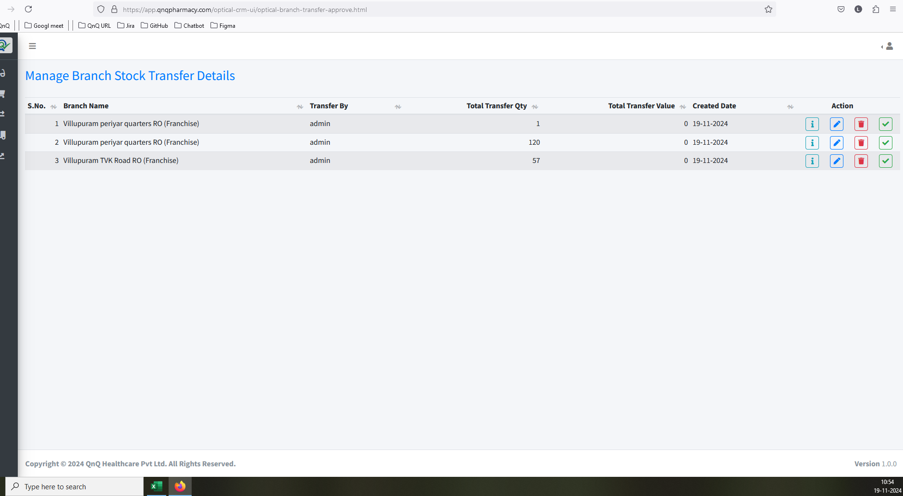 //
12. Dot value not display in Amount column 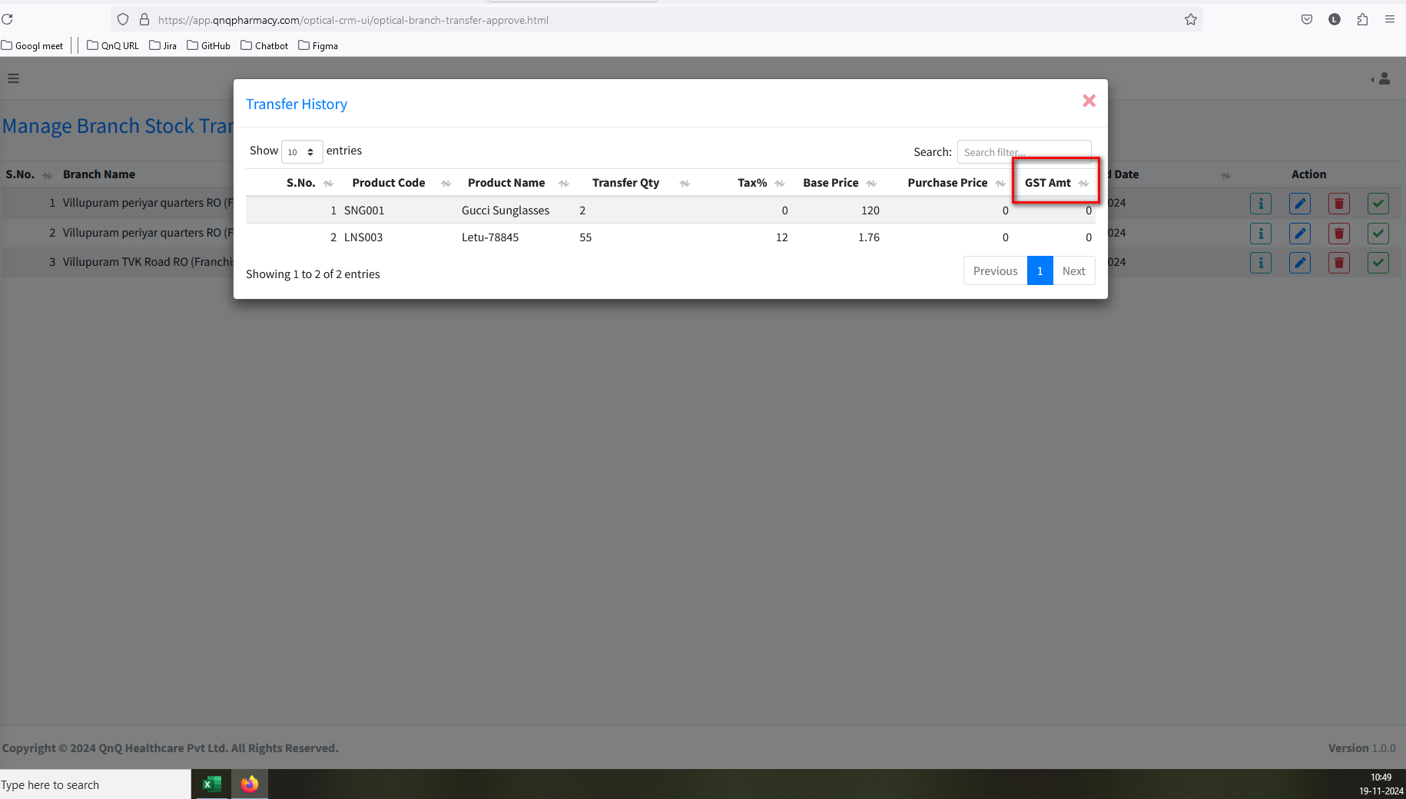 //
13. Column value not display in list grid 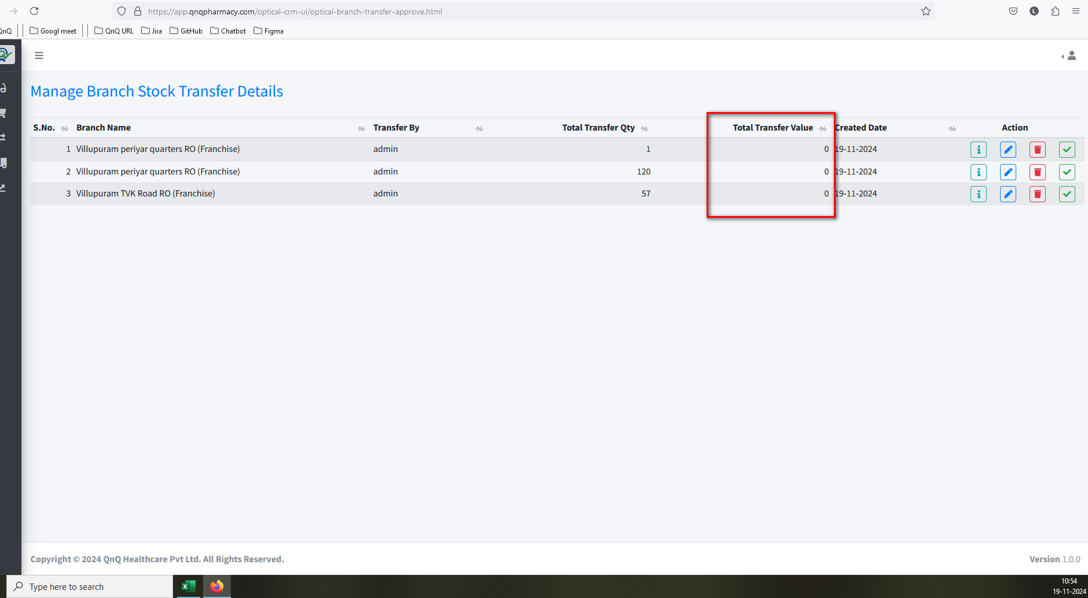 //
14. Success message display mismatch content 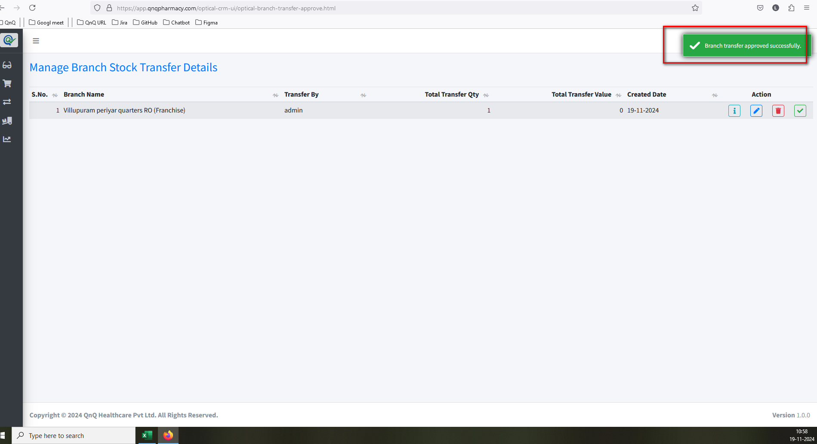 //
15. Delete success message not display while delete the record 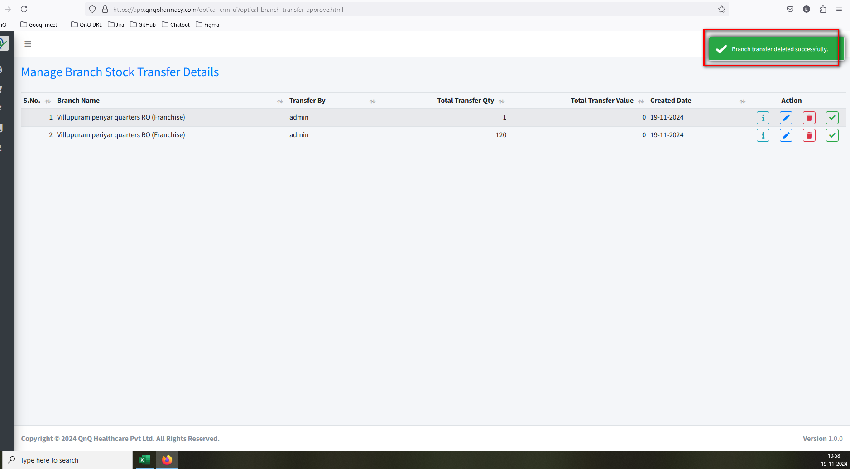 //
16. Unwanted content display in all tool tip 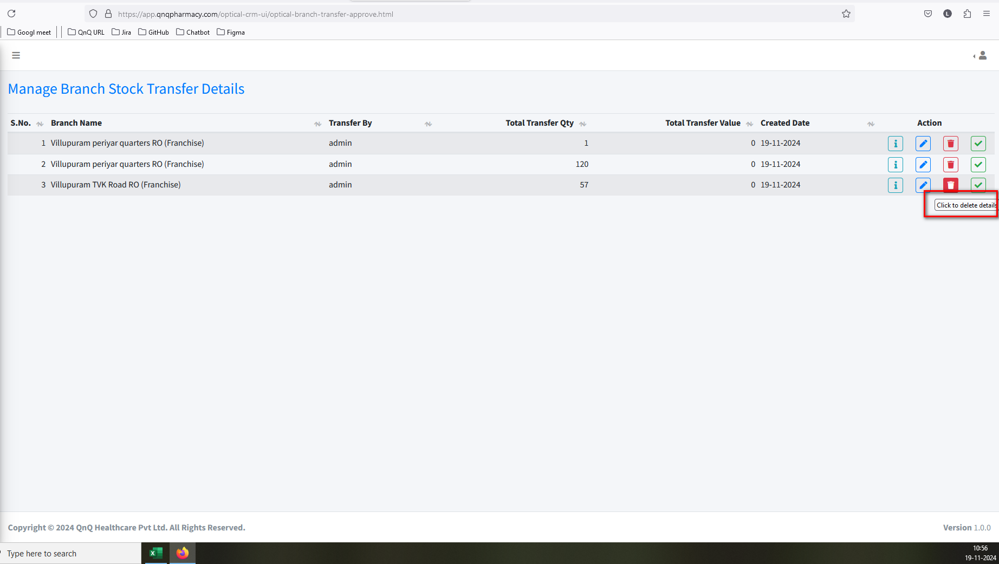 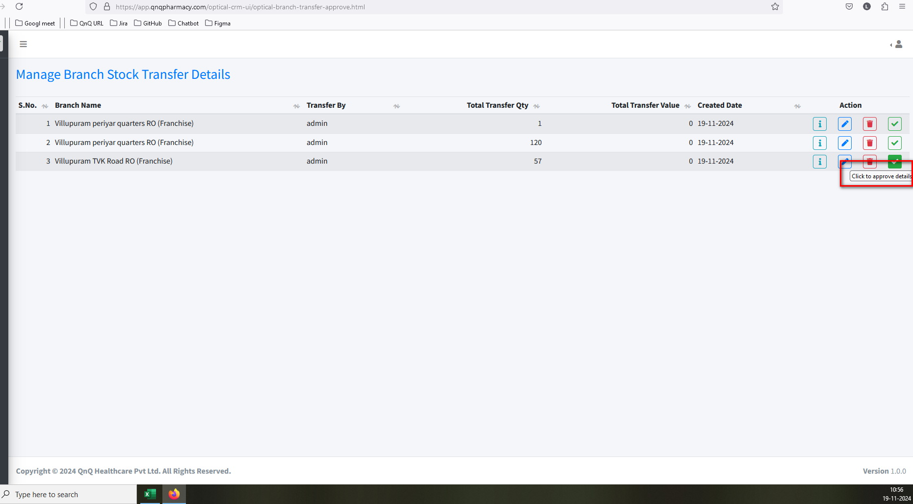 //
17. Mismatch Icon and Tool tip display for Transfer History in approval list grid 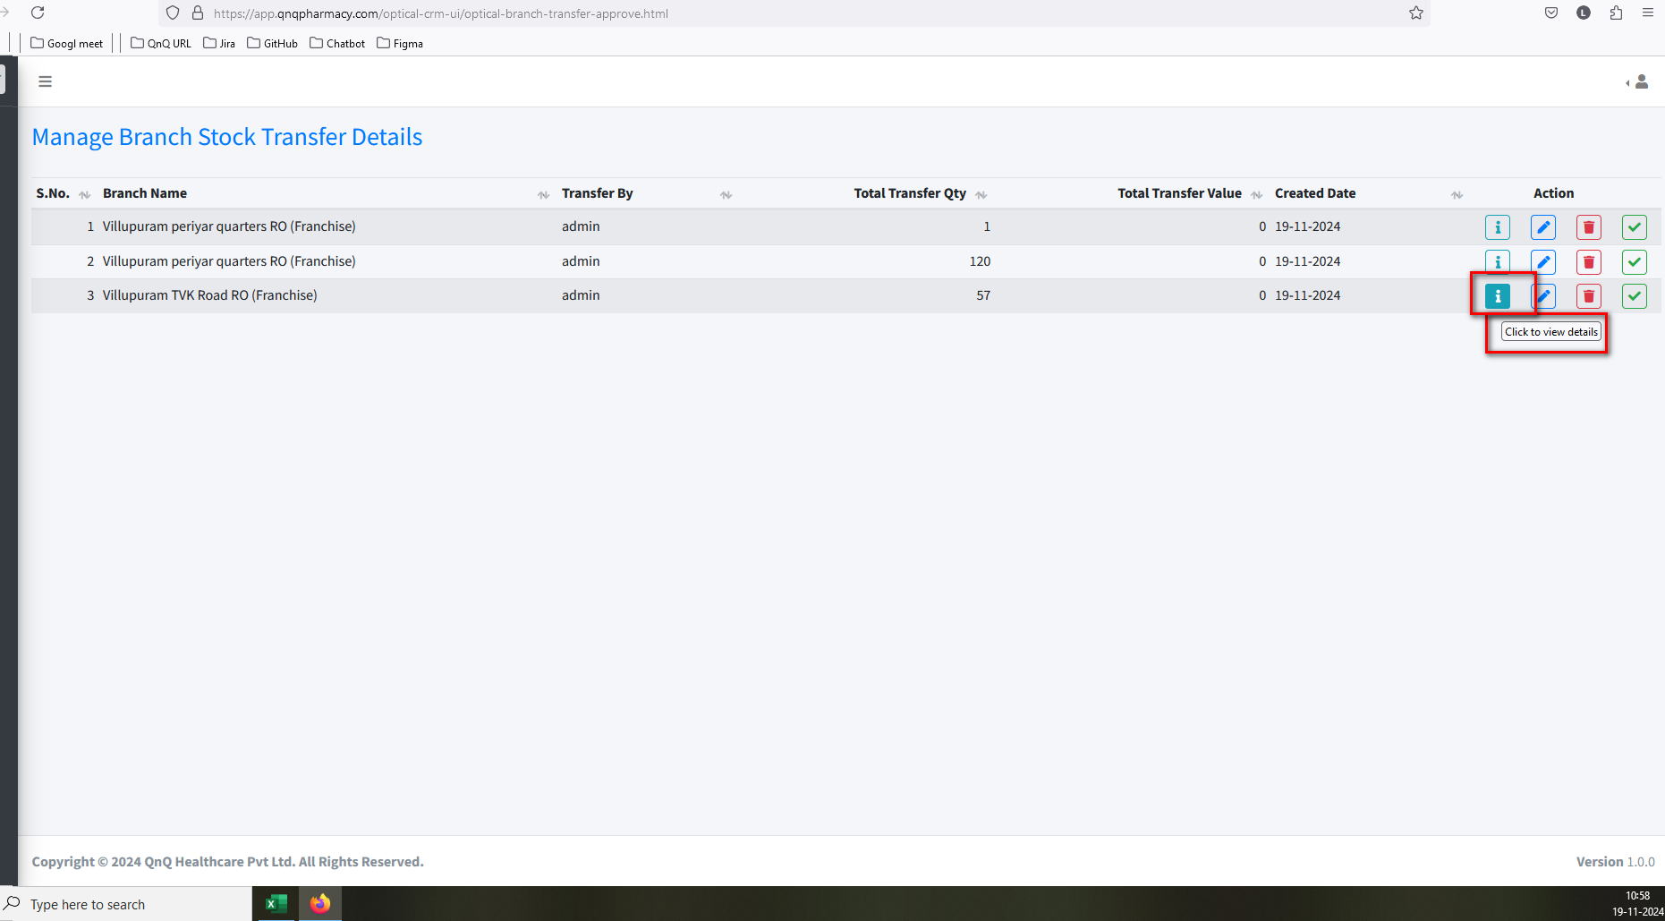 //
18. Pop up getting close without click close button 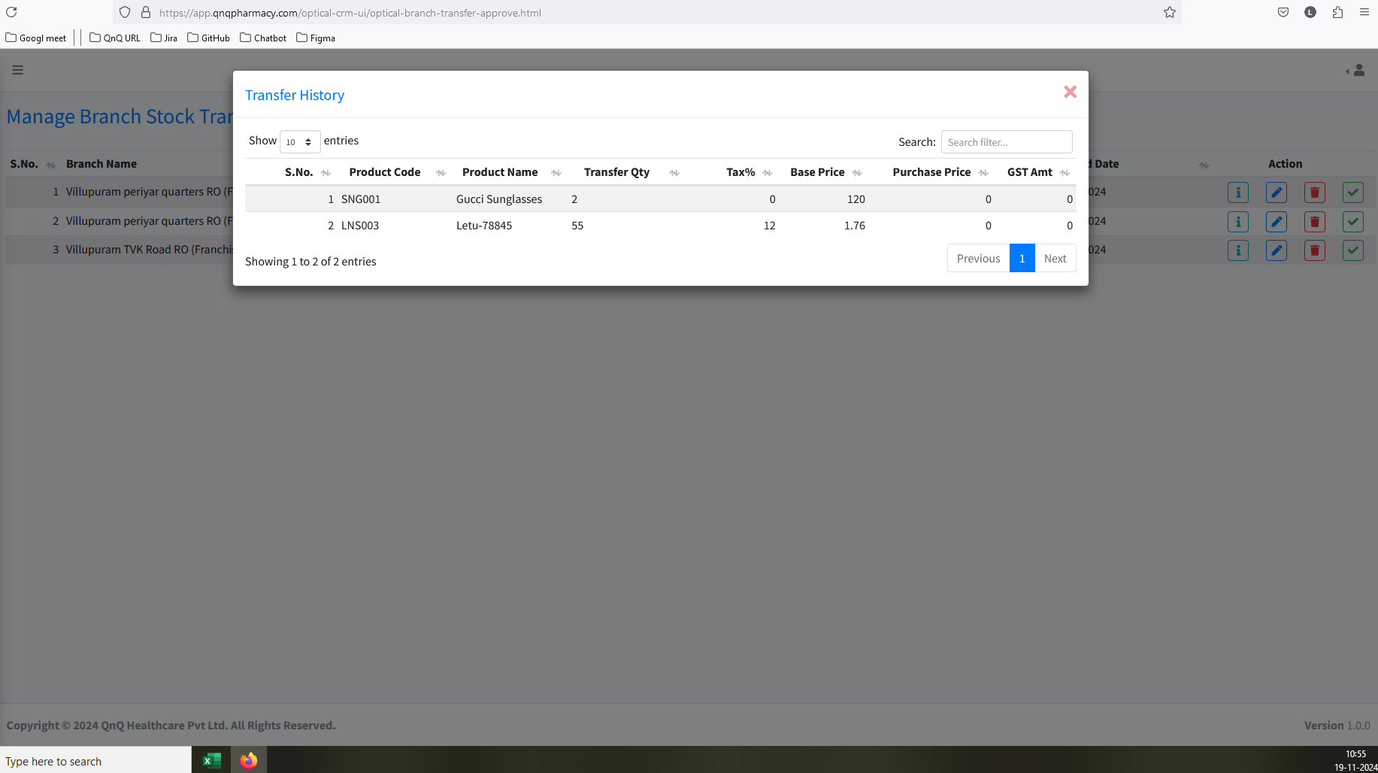 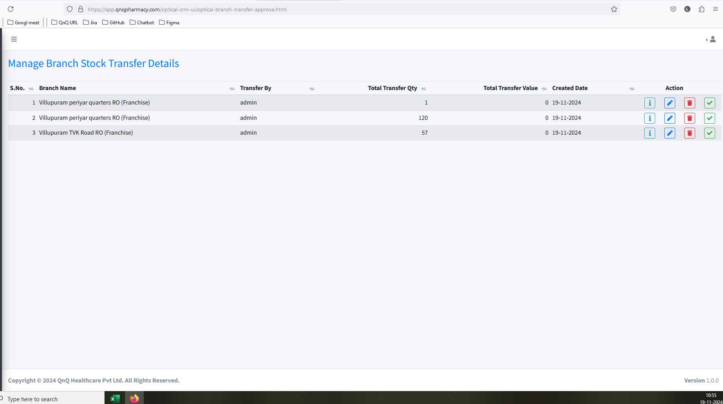 //
19. Page not displays within the outer line/Card 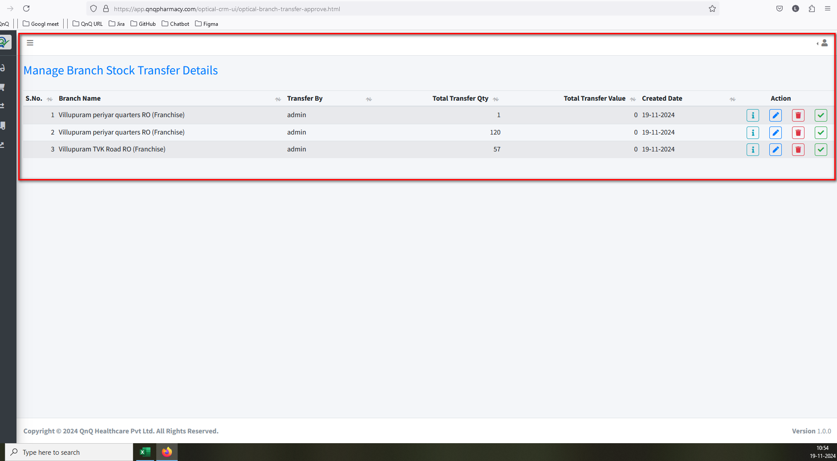 //
20. Dot value not display Qty column header 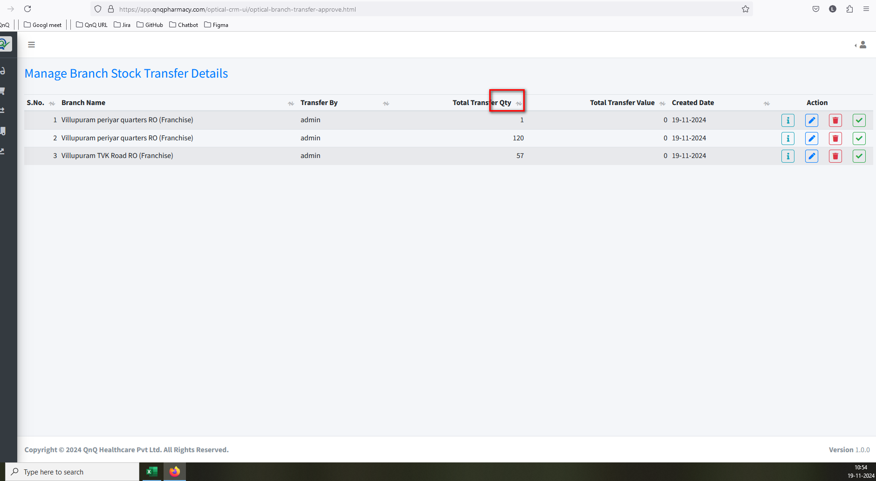 //
21. First letter display as small letter in Showing records content 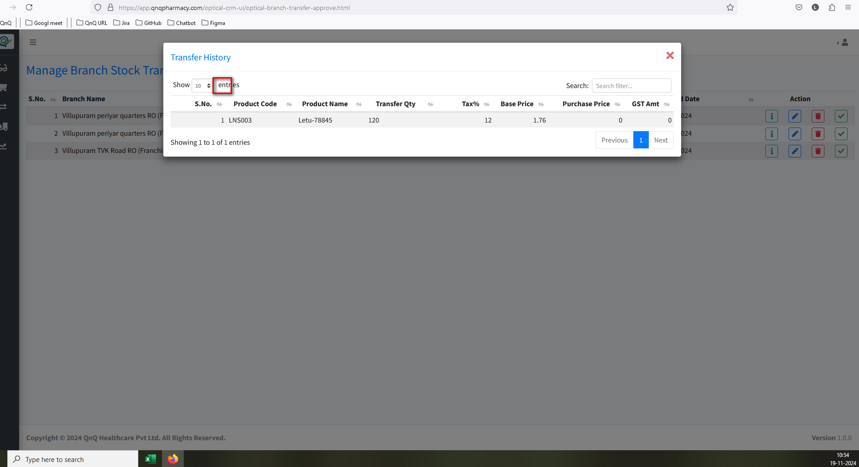 //
22. Tool tip not display for Close icon in every pop up 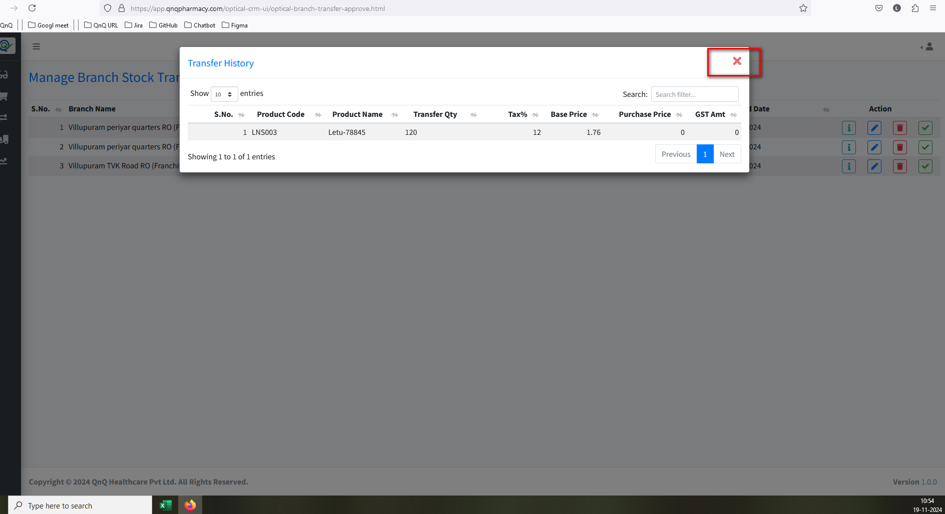 //
23. Improper alignment display in History pop up 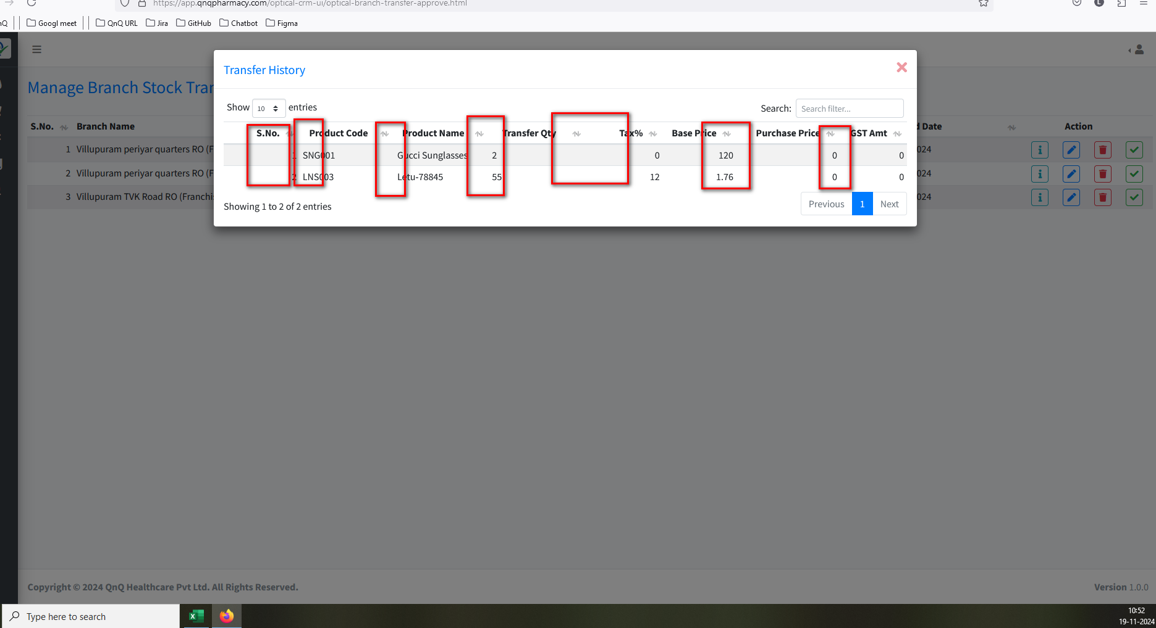 //
24. Refresh icon not available for History pop up 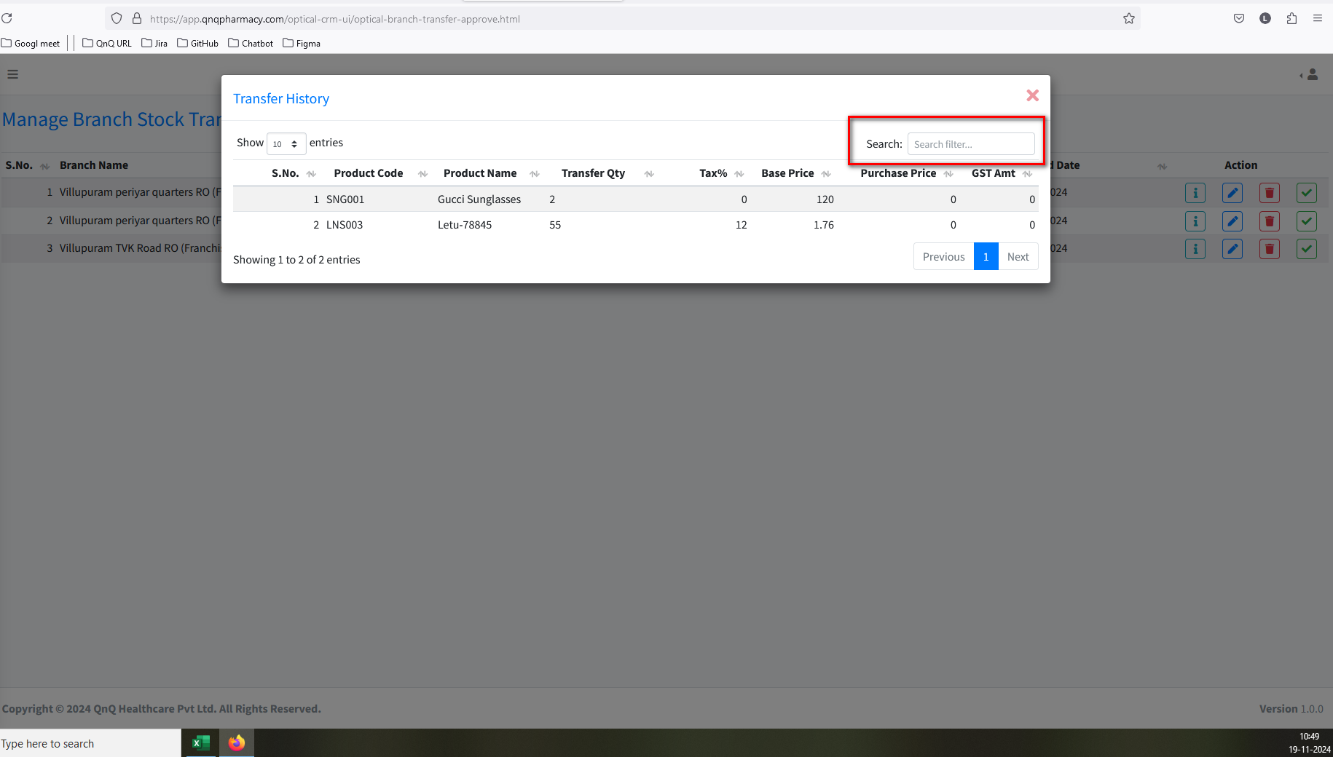 //
25. GST Amount and Purchase price value display as empty in History pop up 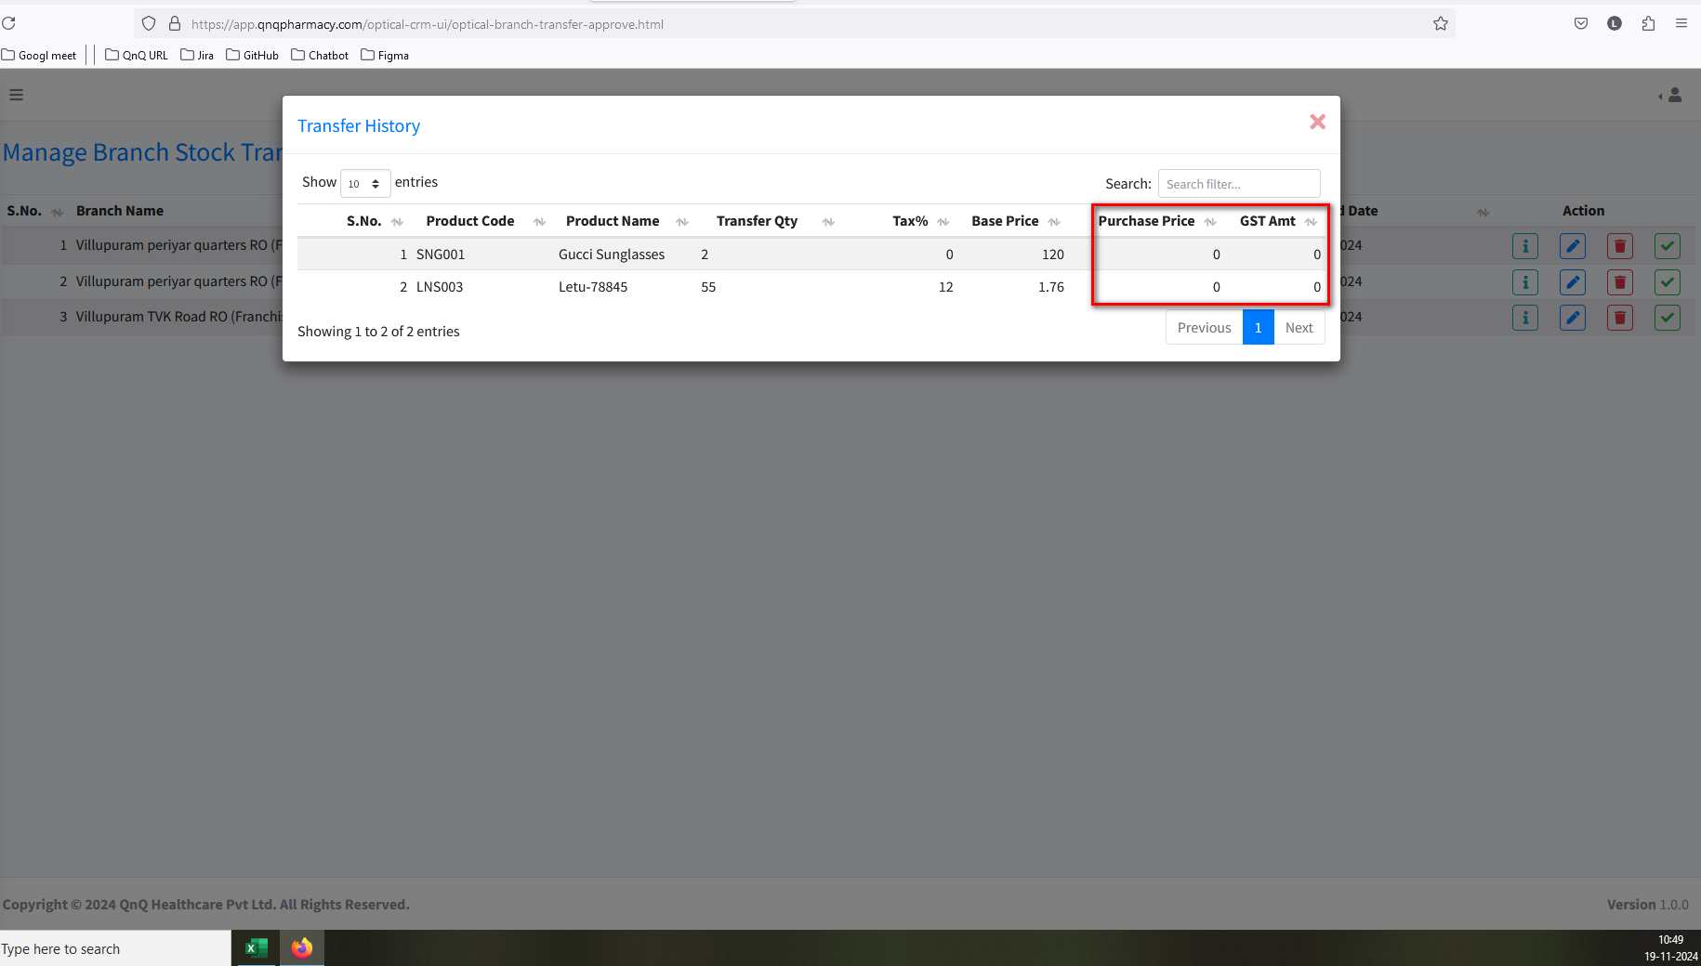 //
26. The content is not centred in the pop-up, and the button appears oversized  